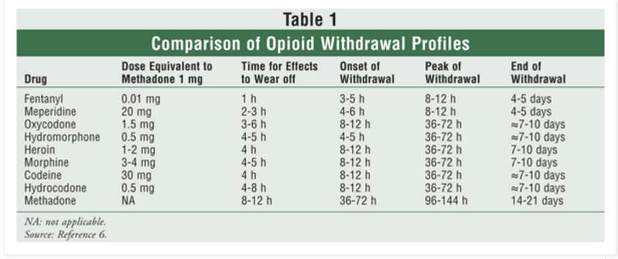Opioid Withdrawal Attenuation Cocktail

Acute Withdrawal:
Clonidine 0.1mg QID x anticipated length of withdrawal. (Check BP & watch for hypotension)
Diarrhea: Hyocosamine 0.125mg every 4-6 hours PRN
Myalgias: Ibuprofen 400mg po QID or Acetamenophen 325mg po Q6hrs
Anxiety: Hydroxyzine 25mg po TID
Insomnia: Trazodone 50-300mg po QHS
Nausea: Ondansetron 8mg po BID x anticipated length of withdrawal. (Check QTc)

Anticipated Withdrawal As A Part of a Planned Taper/Conversion to buprenorphine:
Anxiety: Gabapentin starting at 600 mg TID and titrating up as necessary, max dose 1200mg/TID.
Clonidine 0.1mg QID x anticipated length of withdrawal. (Check BP & watch for hypotension)
Diarrhea: Loperamide 4mg then 2mg QID
Myalgias: Ibuprofen 400mg po QID or Acetamenophen 325mg po Q6hrs
Anxiety: Hydroxyzine 25mg po TID
Insomnia: Trazodone 50-300mg po QHS; Mirtazapine 15-30 mg qHS
Nausea: Ondansetron 8mg po BID x anticipated length of withdrawal. (Check QTc)

